## Exercise #4

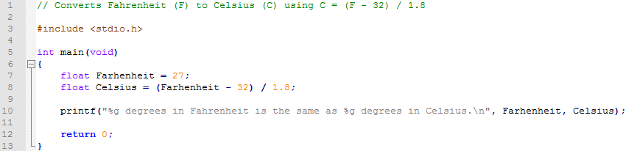

## Exercise #7

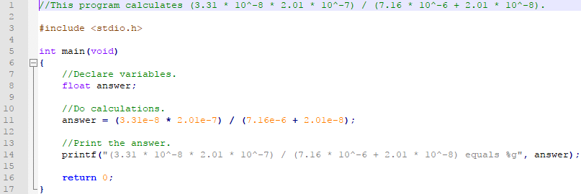

## Exercise #8

